SET 2

Q1. (Algorithms – 5 Marks)
Using AI assistance, generate Python code to implement Merge Sort.
Run the algorithm on the list: 45, 12, 3, 67, 34, 21.
Prompt : Run the algorithm on the list: 45, 12, 3, 67, 34, 21. By using merge sort Algo
Explain the time complexity and how AI improved correctness.
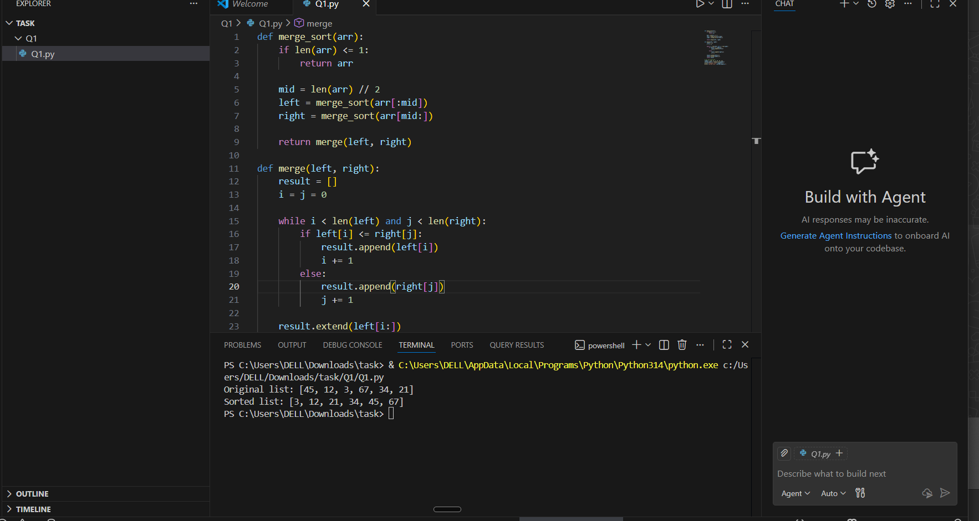

Q2. (Web Frontend – 5 Marks)
Use AI to generate a webpage showing a student registration form with:
- Input fields (Name, Email, Course)
- Submit button
- JavaScript form validation




